

# EGE416 Control Theory - Spring 2021

**COURSE DESIGN PROJECT**

Due Date: Thursday, May 6, 2021

**Your Names:**

Rules for submitting design project

* Groups of two students maximum
* 1 submission per group.
* Create a PDF file with **this cover sheet** and your work
* Upload your file to Blackboard → Course Content → Project → Design Project before:
* Deadline: 5 PM on Thursday, May 6, 2021.

**Abstract: This project deals with the design of a controller to control the altitude of a quadrotor drone. Design specifications are in terms of a desired altitude step response.**

# Problem Description

In this project, you are assigned to develop a controller to regulate the altitude of a quadrotor drone (see Figure 1).

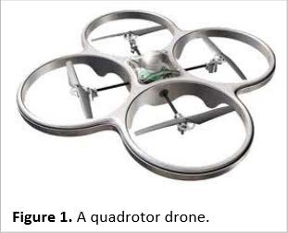

The drone is powered by four propellers, each driven by a DC motor. For simplicity, we assume that all four propellers are always synchronized, and hence they always generate the same amount of lift thrust. Consequently, we ignore any dynamics in the pitch, roll, yaw, and horizontal displacements of the drone.

In this project, we assume that our control input is the DC current of the propeller motors, while the feedback information that is available to us is the altitude of the drone.

# Flight Dynamics

Under the above assumption, we can analyze the altitude control of the drone as a motion in 1 dimension (i.e., vertical) as shown in Figure 2.

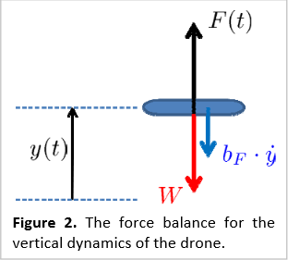

The variable *y* denotes the vertical displacement from a certain reference altitude. That is, at *y*  0 , the drone is hovering at some constant altitude. The control problem in this project is to regulate *y* and make it track a step function.

Here *F* (*t*) denotes the total lift thrust force exerted by the propellers, and *W* denotes the weight of the drone. We also assume that the drone experiences a friction force as it moves vertically through the air. In summary, the dynamics of the altitude of the drone can be captured by the following equation:

*d* 2 *y*(*t*)

## *M*

*dt* 2

 *F* (*t*)  *bF*

*dy*(*t*)

## *dt*

* *Mg*

(1)

Here *bF* is a constant friction coefficient, *M* is the mass of the drone and *g* is the gravitational constant.

# Propulsion Dynamics

We consider a simplified propulsion dynamics, as shown in Figure 3.

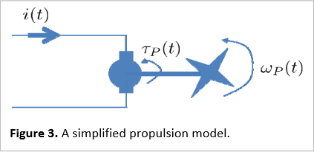

The key assumption is that the motor torque * p* (*t*) is proportional to the current *i*(*t*) :

* p* (*t*)  *K i*(*t*)

(2)

Further, the propeller has a moment of inertia the angular velocity of the propeller * p* (*t*) as:

*J p* and is subject to a friction force such that we can model

*J d p* (*t*)  **

## *p dt*

*p* (*t*)  *bp p*

(*t*)

(3)

Where the constant *bp* is the friction coefficient of the propeller. Finally, we assume that the total lift thrust force is proportional to the angular velocity of the propellers, That is:

*F* (*t*)  *KF  p* (*t* )

(4)

# Table of constants

Use the following values for the constants defined in this problem. Note: all units are compatible with the metric system.

|  |  |  |  |  |  |  |  |  |
| --- | --- | --- | --- | --- | --- | --- | --- | --- |
| Name | Value | Unit | Name | Value | Unit | Name | Value | Unit |
| *M* | 0.5 | Kg | *K* | 2 | N m A-1 | *KF* | 1102 | N s |
| *bF* | 5 | Nm-1s | *J p* | 2 103 | Kg m2 |  |  |  |
| *g* | 9.8 | m s-2 | *bp* | 4 103 | N m s |  |  |  |

# Model Linearization

Observe that because of the weight of the drone, the model given by (1)-(4) is actually non-linear. To be able to use linear control theory, we must first linearize the model. This can be done by offsetting all the variables to cancel de weight of the drone.

**TASK 1 (10 points):** Compute the offset values for the current *i*0 , the propeller torque* p*0 , the propeller angular velocity * p*0 and the lift force *F*0 that cancel the weight of the drone.

Once Task 1 is completed, we can replace equation (1) with its linear version (i.e. with the weight cancelled out) as follows:

*d* 2 *y*(*t*)

## *M dt* 2

 *F* (*t*)  *bF*

*dy*(*t*)

## *dt*

(5)

Now, (2)-(5) form a linear model. The physical interpretation of the variables is changed relative to the offset value. For example, *i*(*t*) is now the deviation of the DC current from the offset value *i*0 , * p* (*t*) is

now the deviation of the propeller angular velocity from the offset value * p*0 , etc.

# Controller Design

Our controller design is based on the diagram of Figure 4:

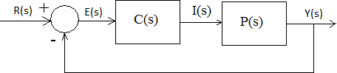

Figure 4: Closed-loop control system

The signal *r*(*t*) is a reference trajectory to be followed by *y*(*t*) . The block *C*(*s*) represents the controller that we are going to design.

**TASK 2 (30 points):** Compute the transfer function from the DC current *i*(*t* ) to the altitude *y*(*t*) . We denote this as the plant transfer function *P*(*s*) .

# Design of a Phase-Lead Controller

We want an overshoot of less than 5%, say *OS*  4.3% , and would like a transient time of about

*tt*  2.5 [s]

**TASK 3 (30 points):** Using the RL technique, design a phase-lead controller *C*(*s*)  *Kc*

*aTs* 1 to

*Ts* 1

satisfy the design specifications. Using MATLAB, verify that the desired roots belong in the RL. Obtain the needed value of controller gain *Kc*

**TASK 4 (20 points):** Simulate the step response using MATLAB and verify the predicted overshoot and transient time. Do the overshoot and transient time agree with our theoretical expectations? Why yes or Why not?

**PRESENTATION OF REPORT (10 points):** A well-written report must be highly structured. MATLAB code should precede every simulation plot. A subsequent explanation of the plot meaning should follow every simulation plot. Explanations should be clear and concise.